Sprint 1 Plan, Civic Duty, Team Civic Duty, Sprint Completion 07/09/18, Revision 2, Revision Date 07/08/18

*Goal:*Our goal for sprint 1 is to get the app’s infrastructure up and running using Django and REACT.

**User Stories:**

***User Story 1:***

As a developer, I want to learn new software so I can make an app.

* + *Task 1:* Learn how to use Django (3 hrs)
  + *Task 2:* Learn how to use REACT (3 hrs)
  + *Task 3:* Learn how to use REST calls (2 hrs)

*Total hours for user story 1:* 8 hrs

***User Story 2:***

As a registered voter, I want to view the candidate’s information so that I can be more informed.

* + *Task 1:* Create a server using Django (1 hr)
  + *Task 2:*Find a list of candidates and their information (use api) (3 hrs)
  + *Task 3:* Create api page for each candidate (use api) (4 hrs)

*Total hours for user story 2:* 8 hrs

***User Story 3:***

As a registered voter, I want to know when elections are so I can vote in the next election.

* + *Task 1:* Find out when the elections are (use api) (1 hr)
  + *Task 2:* Create api page for dates of elections (use api) (2 hr)

*Total hours for user story 3:* 3 hrs

***User Story 4:***

As a non-registered voter, I want to be able to know how to register, so I can vote in the next election.

* + *Task 1:* Find the steps on how to register to vote (use api) (1 hr)
  + *Task 2:*Copy how to register for voting data and format it into our api (2 hr)

*Total hours for user story 4:* 3 hrs

***User Story 5:***

As a register voter, I want to know where the polling station is and what times they are open so I can vote in the next election.

* + *Task 1:*Find a list of polling location (use api) (2 hr)
  + *Task 2:* Be able to find where user is and the locate closest polling station for them (use api) (4 hrs)

**Total hours for user story 5:** 6 hrs

***User Story 6:***

As a citizen, I want to be able to know who my Senators are, so that I can contact them and be informed about my representatives.

* + *Task 1:*Find out what state the user is in (1 hr)
  + *Task 2:*Find out who the senators are (use api) (1 hr)
  + *Task 3:*Create api page for each senator and list their information, contact, and pictures (use api) (3 hrs)

*Total hours for user story 6:*5 hrs

***User Story 7:***

As a registered voter, I want to be able to mail in my votes so that I do not have to go to the polling station.

* + *Task 1:*Find out the different rules for each state about mail in voting (1 hr)
  + *Task 2:*List rules for the user about mail in voting within their state (use api) (1 hr)
  + *Task 3:*Create an api page on how to do mail in voting (use api) (2 hrs)

*Total hours for user story 7:*4 hrs

**Team Roles**

*Nick:* Backend developer

*Daniel:* Backend developer

*Rob:* Scrum Master, Backend developer

*Rui:* Backend developer

*Bryan:* Backend developer

**Initial Task Assignment**

*Nick:* user story 1, task 1, 2, 3; user story 4, task 1 (9 hrs)

*Daniel:* user story 1, task 1, 2, 3 (8 hrs)

*Rob:* user story 1, task 1, 2, 3; user story 2, task 1, 2; user story 3, task 1; user story 5, task 1; user story 6, task 2 (20 hrs)

*Rui*: user story 1, task 1, 2, 3 (8 hrs)

*Bryan*: user story 1, 2, 3; user story 2, task 3; user story 3, task 2; user story 5, task 2; user story 6, task 1, 3 (22 hrs)

**Initial Burnup Chart**

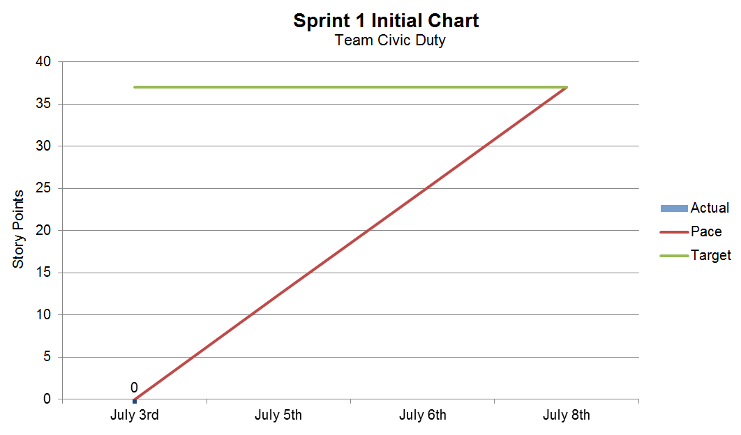

**Initial Scrum Board**

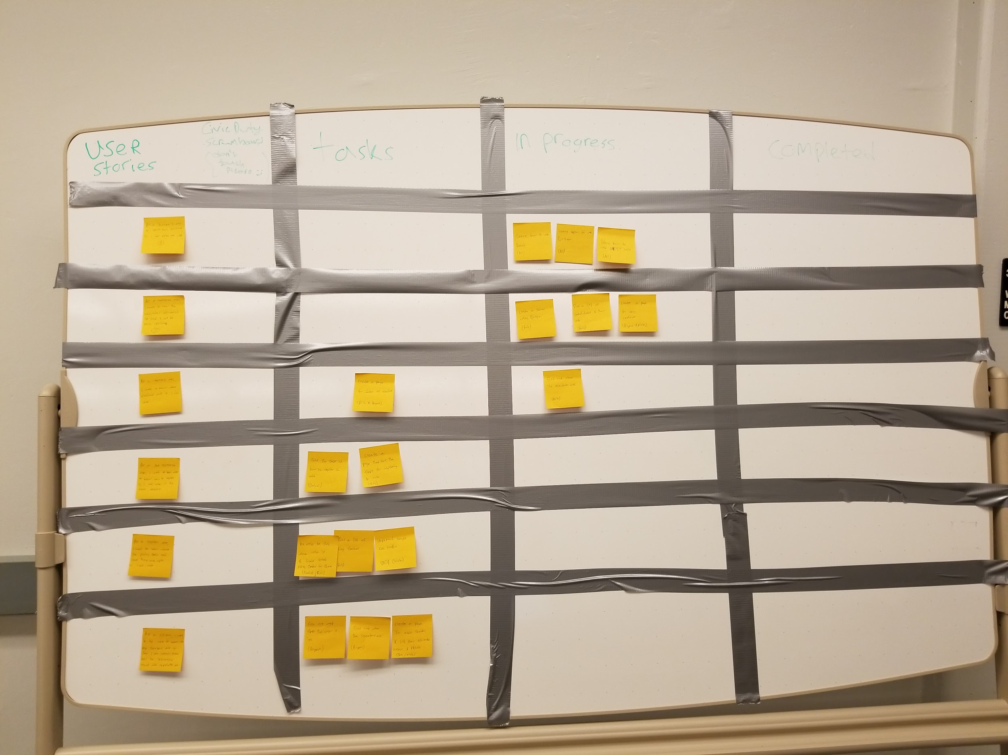

**Scrum Times:** Tuesday: 11 am, Thursday: 2 pm, Friday: TBA